CODA of dose-response MA model: antidepressant

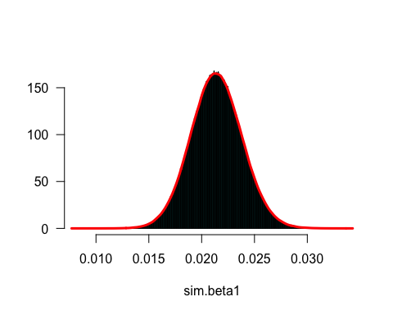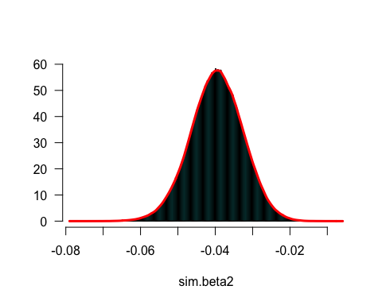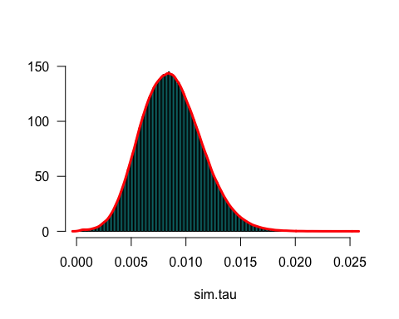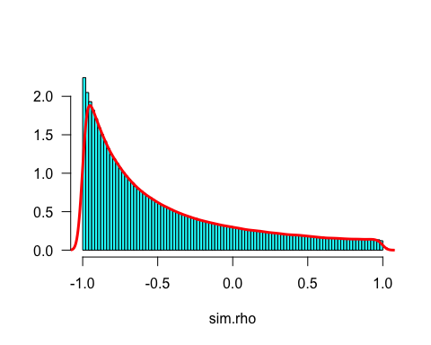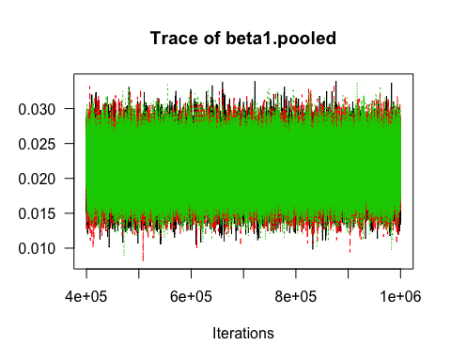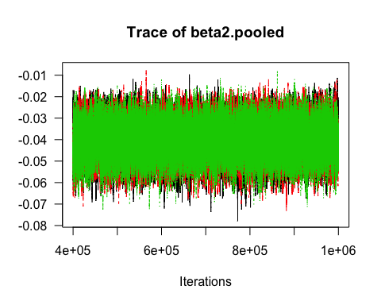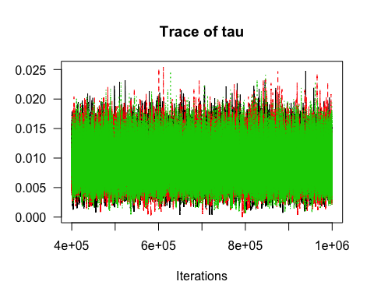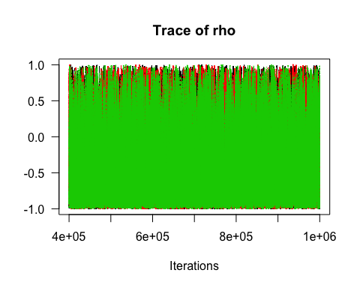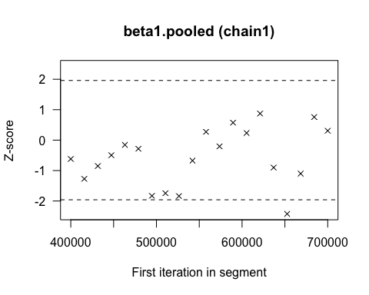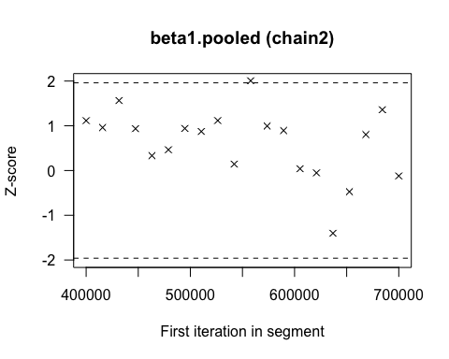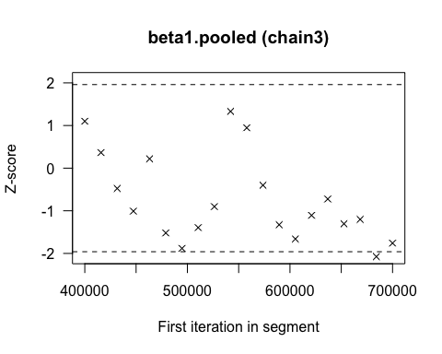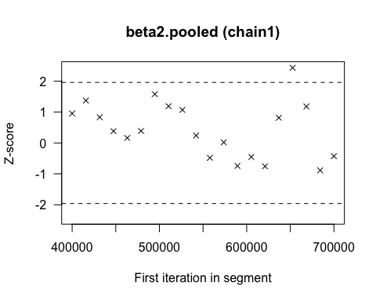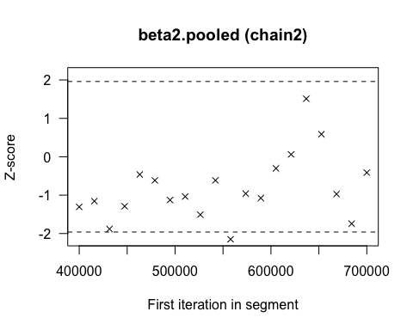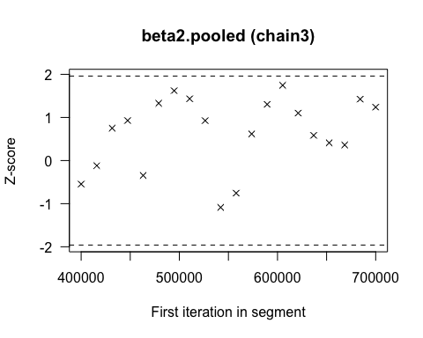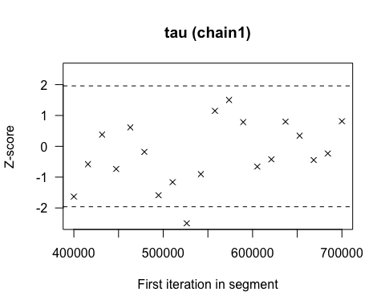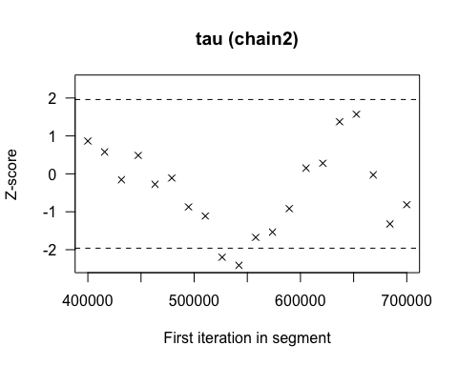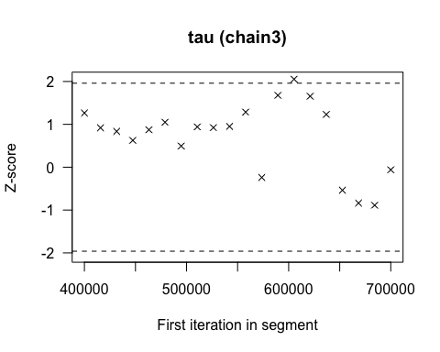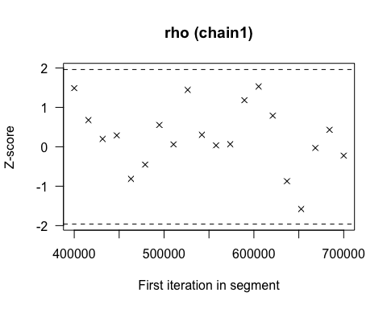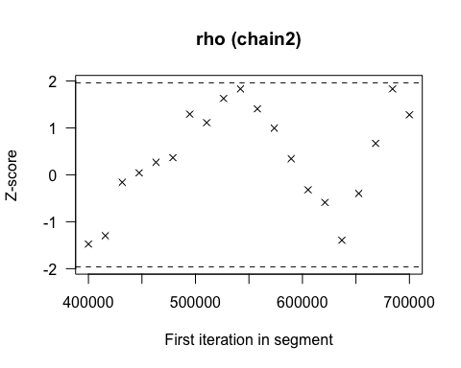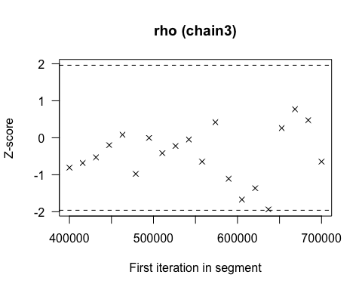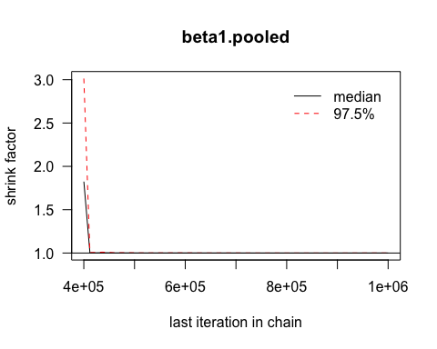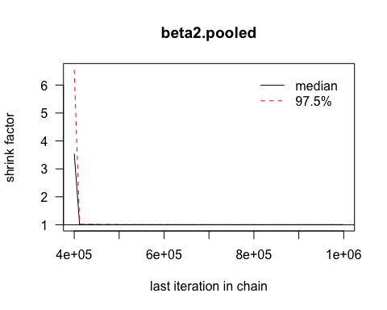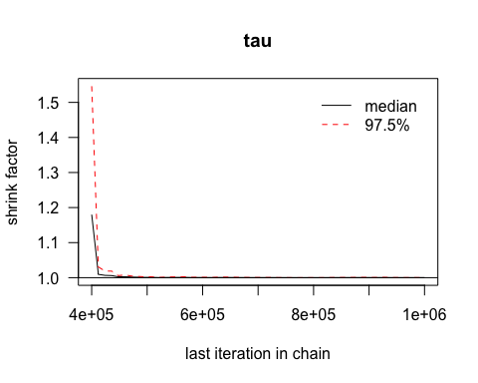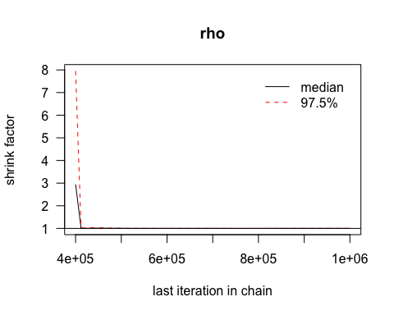

## Potential scale reduction factors:  
##   
## Point est. Upper C.I.  
## beta1.pooled 1 1

## Potential scale reduction factors:  
##   
## Point est. Upper C.I.  
## beta2.pooled 1 1

## Potential scale reduction factors:  
##   
## Point est. Upper C.I.  
## tau 1 1

## Potential scale reduction factors:  
##   
## Point est. Upper C.I.  
## rho 1 1

## beta1.pooled   
## 29481.51

## beta2.pooled   
## 12616.86

## tau   
## 16459.02

## rho   
## 9089.852

## [[1]]  
##   
## Quantile (q) = 0.025  
## Accuracy (r) = +/- 0.005  
## Probability (s) = 0.95   
##   
## Burn-in Total Lower bound Dependence  
## (M) (N) (Nmin) factor (I)  
## beta1.pooled 66 98758 3746 26.4   
##   
##   
## [[2]]  
##   
## Quantile (q) = 0.025  
## Accuracy (r) = +/- 0.005  
## Probability (s) = 0.95   
##   
## Burn-in Total Lower bound Dependence  
## (M) (N) (Nmin) factor (I)  
## beta1.pooled 69 101085 3746 27   
##   
##   
## [[3]]  
##   
## Quantile (q) = 0.025  
## Accuracy (r) = +/- 0.005  
## Probability (s) = 0.95   
##   
## Burn-in Total Lower bound Dependence  
## (M) (N) (Nmin) factor (I)  
## beta1.pooled 75 101875 3746 27.2

## [[1]]  
##   
## Quantile (q) = 0.025  
## Accuracy (r) = +/- 0.005  
## Probability (s) = 0.95   
##   
## Burn-in Total Lower bound Dependence  
## (M) (N) (Nmin) factor (I)  
## beta2.pooled 195 219297 3746 58.5   
##   
##   
## [[2]]  
##   
## Quantile (q) = 0.025  
## Accuracy (r) = +/- 0.005  
## Probability (s) = 0.95   
##   
## Burn-in Total Lower bound Dependence  
## (M) (N) (Nmin) factor (I)  
## beta2.pooled 170 193324 3746 51.6   
##   
##   
## [[3]]  
##   
## Quantile (q) = 0.025  
## Accuracy (r) = +/- 0.005  
## Probability (s) = 0.95   
##   
## Burn-in Total Lower bound Dependence  
## (M) (N) (Nmin) factor (I)  
## beta2.pooled 190 220894 3746 59

## [[1]]  
##   
## Quantile (q) = 0.025  
## Accuracy (r) = +/- 0.005  
## Probability (s) = 0.95   
##   
## Burn-in Total Lower bound Dependence  
## (M) (N) (Nmin) factor (I)  
## tau 276 320666 3746 85.6   
##   
##   
## [[2]]  
##   
## Quantile (q) = 0.025  
## Accuracy (r) = +/- 0.005  
## Probability (s) = 0.95   
##   
## Burn-in Total Lower bound Dependence  
## (M) (N) (Nmin) factor (I)  
## tau 328 371214 3746 99.1   
##   
##   
## [[3]]  
##   
## Quantile (q) = 0.025  
## Accuracy (r) = +/- 0.005  
## Probability (s) = 0.95   
##   
## Burn-in Total Lower bound Dependence  
## (M) (N) (Nmin) factor (I)  
## tau 280 312240 3746 83.4

## [[1]]  
##   
## Quantile (q) = 0.025  
## Accuracy (r) = +/- 0.005  
## Probability (s) = 0.95   
##   
## Burn-in Total Lower bound Dependence  
## (M) (N) (Nmin) factor (I)  
## rho 315 354555 3746 94.6   
##   
##   
## [[2]]  
##   
## Quantile (q) = 0.025  
## Accuracy (r) = +/- 0.005  
## Probability (s) = 0.95   
##   
## Burn-in Total Lower bound Dependence  
## (M) (N) (Nmin) factor (I)  
## rho 441 535248 3746 143   
##   
##   
## [[3]]  
##   
## Quantile (q) = 0.025  
## Accuracy (r) = +/- 0.005  
## Probability (s) = 0.95   
##   
## Burn-in Total Lower bound Dependence  
## (M) (N) (Nmin) factor (I)  
## rho 315 347625 3746 92.8

## [[1]]  
##   
## Stationarity start p-value  
## test iteration   
## beta1.pooled passed 1 0.435   
##   
## Halfwidth Mean Halfwidth  
## test   
## beta1.pooled passed 0.0214 4.89e-05   
##   
## [[2]]  
##   
## Stationarity start p-value  
## test iteration   
## beta1.pooled passed 1 0.277   
##   
## Halfwidth Mean Halfwidth  
## test   
## beta1.pooled passed 0.0214 4.75e-05   
##   
## [[3]]  
##   
## Stationarity start p-value  
## test iteration   
## beta1.pooled passed 1 0.354   
##   
## Halfwidth Mean Halfwidth  
## test   
## beta1.pooled passed 0.0215 4.81e-05

## [[1]]  
##   
## Stationarity start p-value  
## test iteration   
## beta2.pooled passed 1 0.477   
##   
## Halfwidth Mean Halfwidth  
## test   
## beta2.pooled passed -0.0396 0.000219   
##   
## [[2]]  
##   
## Stationarity start p-value  
## test iteration   
## beta2.pooled passed 1 0.14   
##   
## Halfwidth Mean Halfwidth  
## test   
## beta2.pooled passed -0.0395 0.000208   
##   
## [[3]]  
##   
## Stationarity start p-value  
## test iteration   
## beta2.pooled passed 1 0.621   
##   
## Halfwidth Mean Halfwidth  
## test   
## beta2.pooled passed -0.0398 0.000212

## [[1]]  
##   
## Stationarity start p-value  
## test iteration   
## tau passed 1 0.198   
##   
## Halfwidth Mean Halfwidth  
## test   
## tau passed 0.00869 7.15e-05   
##   
## [[2]]  
##   
## Stationarity start p-value  
## test iteration   
## tau passed 1 0.526   
##   
## Halfwidth Mean Halfwidth  
## test   
## tau passed 0.0087 7.46e-05   
##   
## [[3]]  
##   
## Stationarity start p-value  
## test iteration   
## tau passed 1 0.123   
##   
## Halfwidth Mean Halfwidth  
## test   
## tau passed 0.00866 7.43e-05

## [[1]]  
##   
## Stationarity start p-value  
## test iteration   
## rho passed 1 0.542   
##   
## Halfwidth Mean Halfwidth  
## test   
## rho passed -0.458 0.0176   
##   
## [[2]]  
##   
## Stationarity start p-value  
## test iteration   
## rho passed 1 0.486   
##   
## Halfwidth Mean Halfwidth  
## test   
## rho passed -0.469 0.018   
##   
## [[3]]  
##   
## Stationarity start p-value  
## test iteration   
## rho passed 1 0.4   
##   
## Halfwidth Mean Halfwidth  
## test   
## rho passed -0.444 0.019

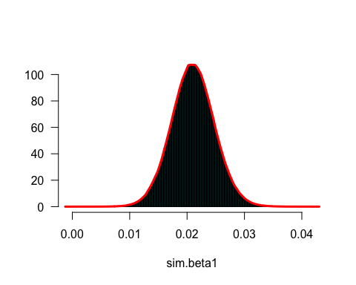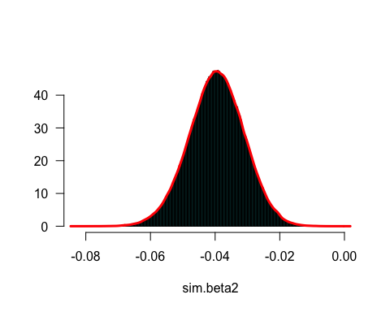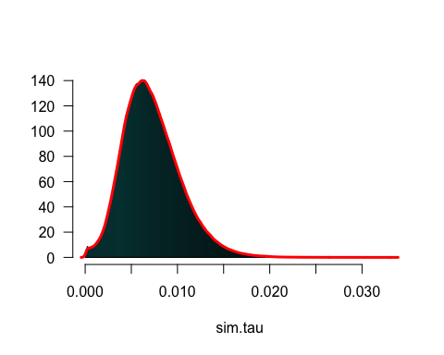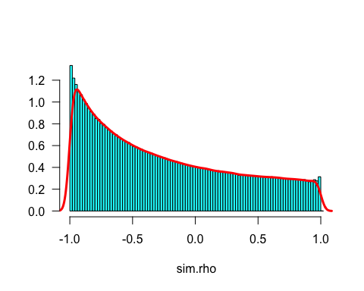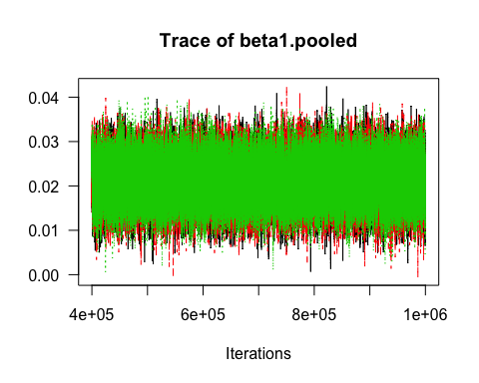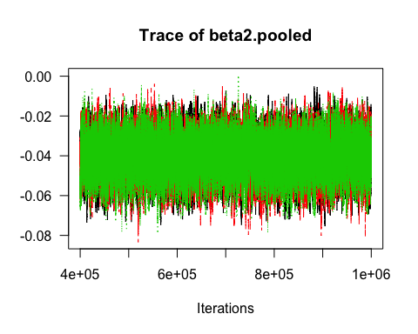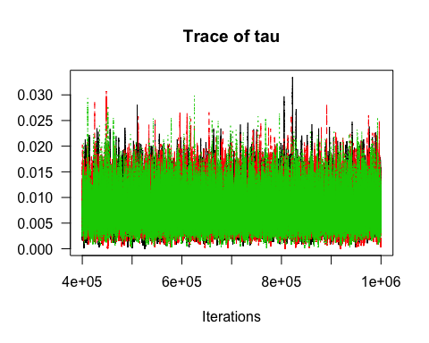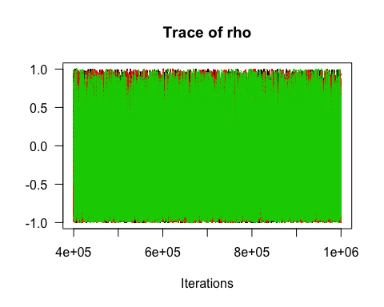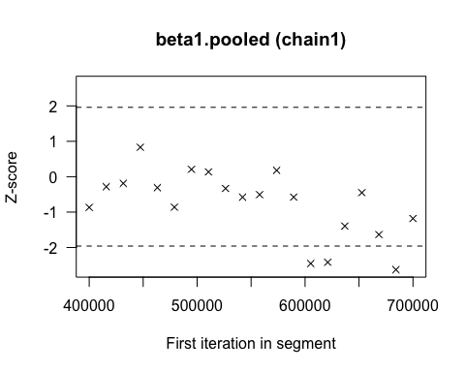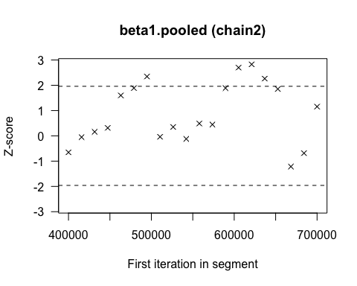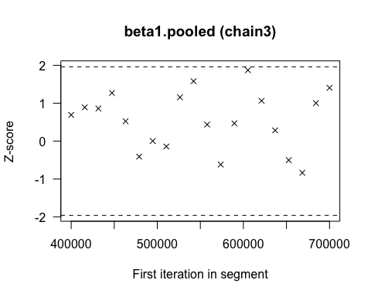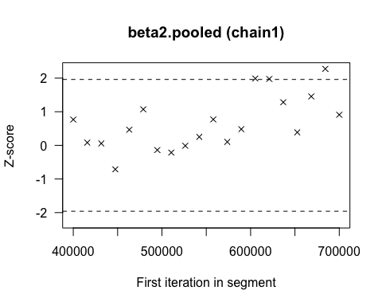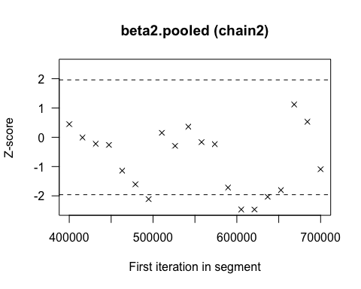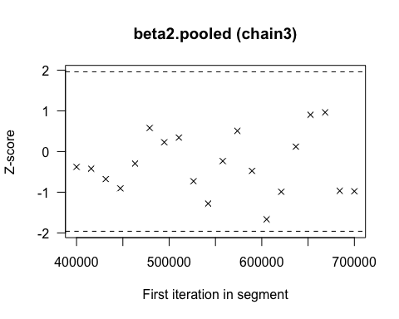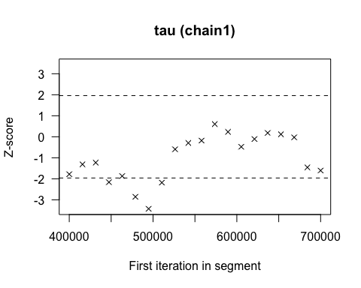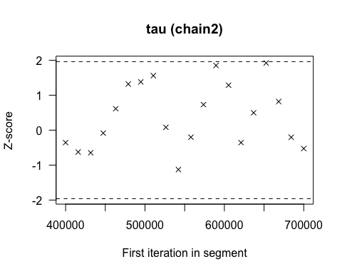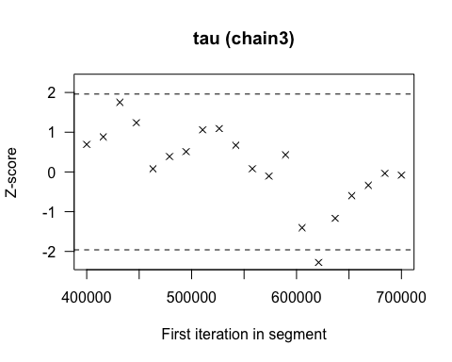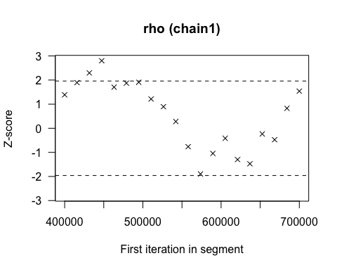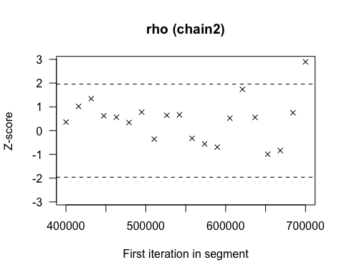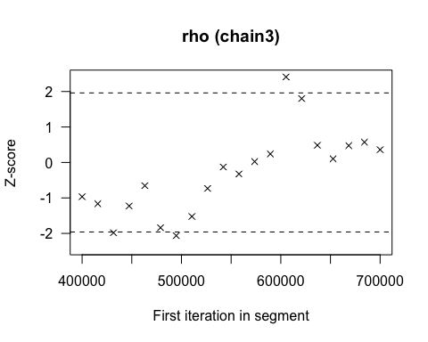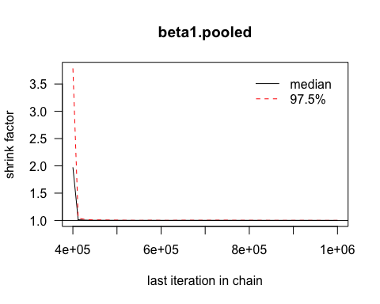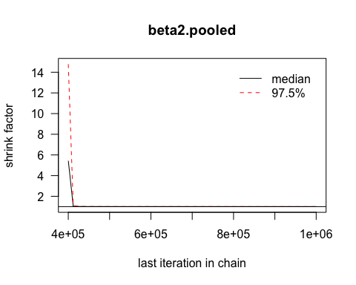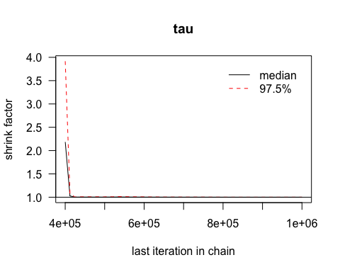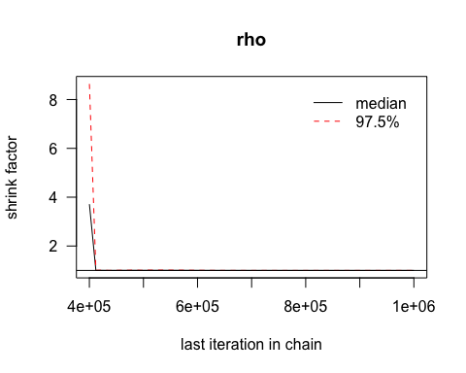

## Potential scale reduction factors:  
##   
## Point est. Upper C.I.  
## beta1.pooled 1 1

## Potential scale reduction factors:  
##   
## Point est. Upper C.I.  
## beta2.pooled 1 1

## Potential scale reduction factors:  
##   
## Point est. Upper C.I.  
## tau 1 1

## Potential scale reduction factors:  
##   
## Point est. Upper C.I.  
## rho 1 1

## beta1.pooled   
## 14285.97

## beta2.pooled   
## 7371.669

## tau   
## 12831.53

## rho   
## 9629.117

## [[1]]  
##   
## Quantile (q) = 0.025  
## Accuracy (r) = +/- 0.005  
## Probability (s) = 0.95   
##   
## Burn-in Total Lower bound Dependence  
## (M) (N) (Nmin) factor (I)  
## beta1.pooled 148 175602 3746 46.9   
##   
##   
## [[2]]  
##   
## Quantile (q) = 0.025  
## Accuracy (r) = +/- 0.005  
## Probability (s) = 0.95   
##   
## Burn-in Total Lower bound Dependence  
## (M) (N) (Nmin) factor (I)  
## beta1.pooled 204 248268 3746 66.3   
##   
##   
## [[3]]  
##   
## Quantile (q) = 0.025  
## Accuracy (r) = +/- 0.005  
## Probability (s) = 0.95   
##   
## Burn-in Total Lower bound Dependence  
## (M) (N) (Nmin) factor (I)  
## beta1.pooled 132 154440 3746 41.2

## [[1]]  
##   
## Quantile (q) = 0.025  
## Accuracy (r) = +/- 0.005  
## Probability (s) = 0.95   
##   
## Burn-in Total Lower bound Dependence  
## (M) (N) (Nmin) factor (I)  
## beta2.pooled 228 264024 3746 70.5   
##   
##   
## [[2]]  
##   
## Quantile (q) = 0.025  
## Accuracy (r) = +/- 0.005  
## Probability (s) = 0.95   
##   
## Burn-in Total Lower bound Dependence  
## (M) (N) (Nmin) factor (I)  
## beta2.pooled 320 347968 3746 92.9   
##   
##   
## [[3]]  
##   
## Quantile (q) = 0.025  
## Accuracy (r) = +/- 0.005  
## Probability (s) = 0.95   
##   
## Burn-in Total Lower bound Dependence  
## (M) (N) (Nmin) factor (I)  
## beta2.pooled 282 329893 3746 88.1

## [[1]]  
##   
## Quantile (q) = 0.025  
## Accuracy (r) = +/- 0.005  
## Probability (s) = 0.95   
##   
## Burn-in Total Lower bound Dependence  
## (M) (N) (Nmin) factor (I)  
## tau 576 640064 3746 171   
##   
##   
## [[2]]  
##   
## Quantile (q) = 0.025  
## Accuracy (r) = +/- 0.005  
## Probability (s) = 0.95   
##   
## Burn-in Total Lower bound Dependence  
## (M) (N) (Nmin) factor (I)  
## tau 704 797544 3746 213   
##   
##   
## [[3]]  
##   
## Quantile (q) = 0.025  
## Accuracy (r) = +/- 0.005  
## Probability (s) = 0.95   
##   
## Burn-in Total Lower bound Dependence  
## (M) (N) (Nmin) factor (I)  
## tau 490 515529 3746 138

## [[1]]  
##   
## Quantile (q) = 0.025  
## Accuracy (r) = +/- 0.005  
## Probability (s) = 0.95   
##   
## Burn-in Total Lower bound Dependence  
## (M) (N) (Nmin) factor (I)  
## rho 392 463981 3746 124   
##   
##   
## [[2]]  
##   
## Quantile (q) = 0.025  
## Accuracy (r) = +/- 0.005  
## Probability (s) = 0.95   
##   
## Burn-in Total Lower bound Dependence  
## (M) (N) (Nmin) factor (I)  
## rho 399 442776 3746 118   
##   
##   
## [[3]]  
##   
## Quantile (q) = 0.025  
## Accuracy (r) = +/- 0.005  
## Probability (s) = 0.95   
##   
## Burn-in Total Lower bound Dependence  
## (M) (N) (Nmin) factor (I)  
## rho 376 389019 3746 104

## [[1]]  
##   
## Stationarity start p-value  
## test iteration   
## beta1.pooled passed 1 0.229   
##   
## Halfwidth Mean Halfwidth  
## test   
## beta1.pooled passed 0.0209 0.000105   
##   
## [[2]]  
##   
## Stationarity start p-value  
## test iteration   
## beta1.pooled passed 1 0.112   
##   
## Halfwidth Mean Halfwidth  
## test   
## beta1.pooled passed 0.021 0.000108   
##   
## [[3]]  
##   
## Stationarity start p-value  
## test iteration   
## beta1.pooled passed 1 0.541   
##   
## Halfwidth Mean Halfwidth  
## test   
## beta1.pooled passed 0.0211 0.000108

## [[1]]  
##   
## Stationarity start p-value  
## test iteration   
## beta2.pooled passed 1 0.354   
##   
## Halfwidth Mean Halfwidth  
## test   
## beta2.pooled passed -0.0394 0.000332   
##   
## [[2]]  
##   
## Stationarity start p-value  
## test iteration   
## beta2.pooled passed 1 0.173   
##   
## Halfwidth Mean Halfwidth  
## test   
## beta2.pooled passed -0.0395 0.000341   
##   
## [[3]]  
##   
## Stationarity start p-value  
## test iteration   
## beta2.pooled passed 1 0.829   
##   
## Halfwidth Mean Halfwidth  
## test   
## beta2.pooled passed -0.0398 0.000344

## [[1]]  
##   
## Stationarity start p-value  
## test iteration   
## tau passed 60001 0.0715   
##   
## Halfwidth Mean Halfwidth  
## test   
## tau passed 0.00724 9.55e-05   
##   
## [[2]]  
##   
## Stationarity start p-value  
## test iteration   
## tau passed 1 0.769   
##   
## Halfwidth Mean Halfwidth  
## test   
## tau passed 0.00726 9.74e-05   
##   
## [[3]]  
##   
## Stationarity start p-value  
## test iteration   
## tau passed 1 0.48   
##   
## Halfwidth Mean Halfwidth  
## test   
## tau passed 0.00724 8.94e-05

## [[1]]  
##   
## Stationarity start p-value  
## test iteration   
## rho passed 1 0.105   
##   
## Halfwidth Mean Halfwidth  
## test   
## rho passed -0.246 0.0199   
##   
## [[2]]  
##   
## Stationarity start p-value  
## test iteration   
## rho passed 1 0.529   
##   
## Halfwidth Mean Halfwidth  
## test   
## rho passed -0.252 0.0197   
##   
## [[3]]  
##   
## Stationarity start p-value  
## test iteration   
## rho passed 1 0.292   
##   
## Halfwidth Mean Halfwidth  
## test   
## rho passed -0.245 0.0202

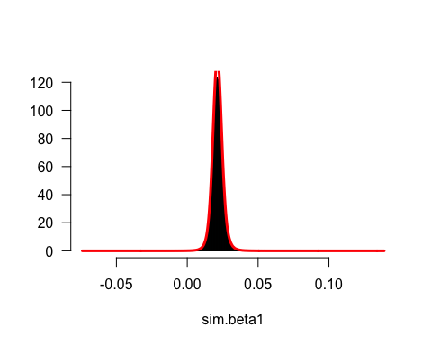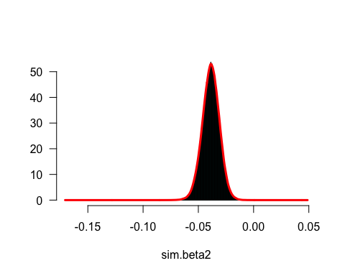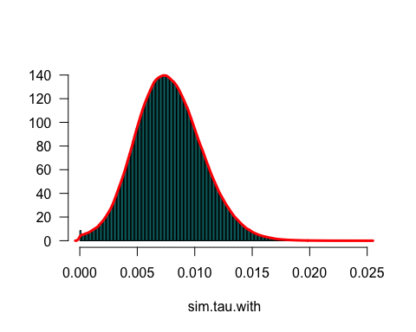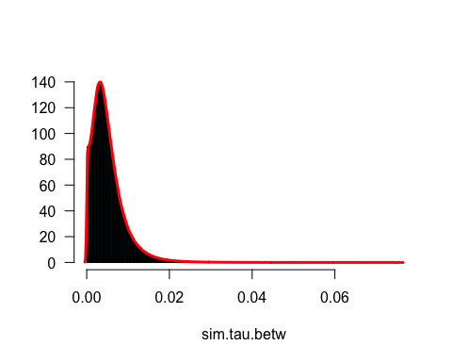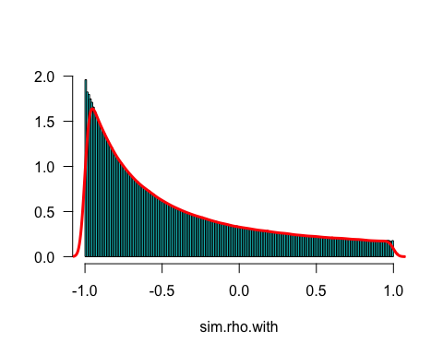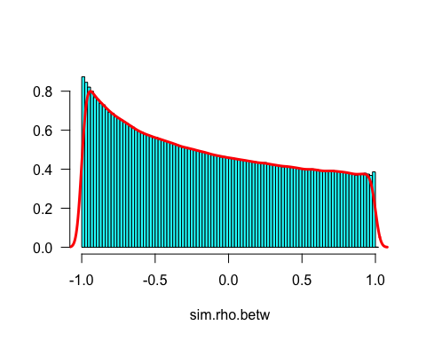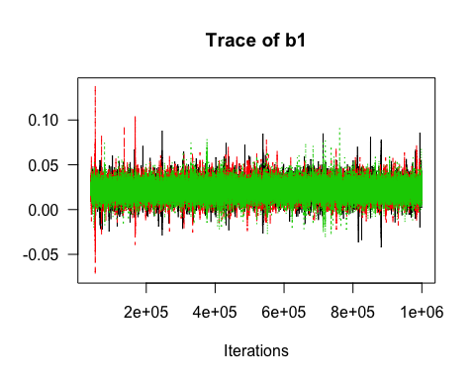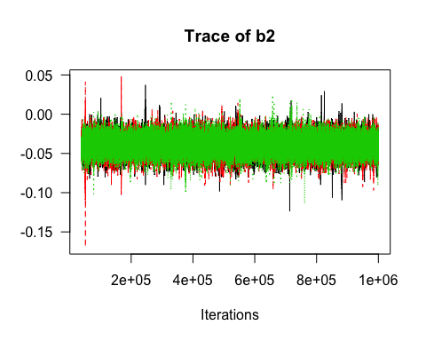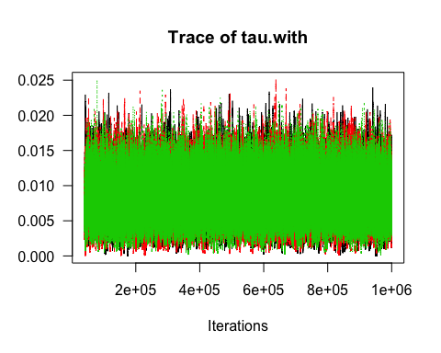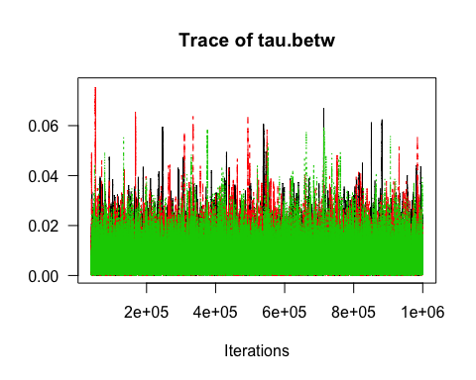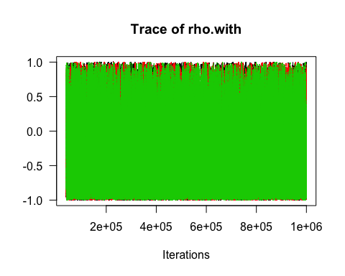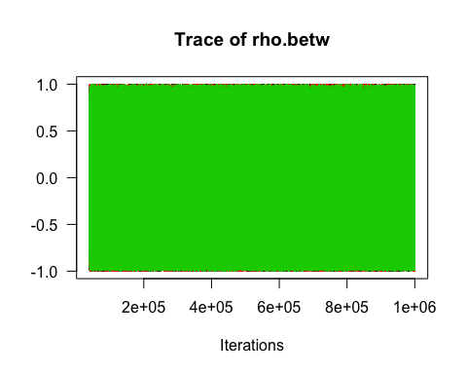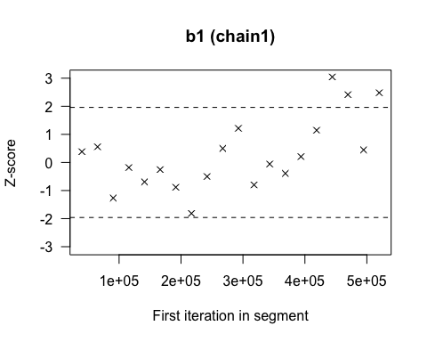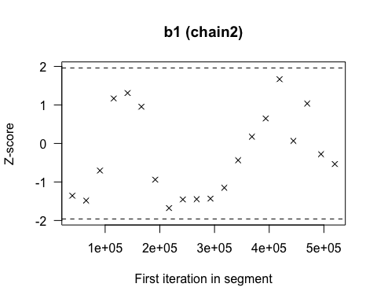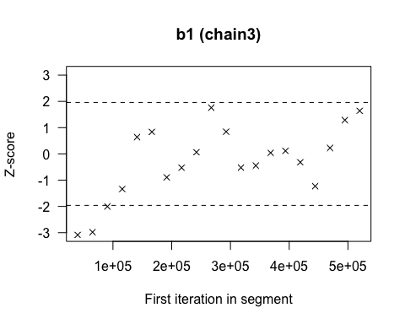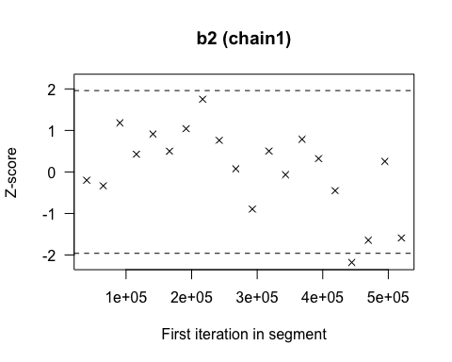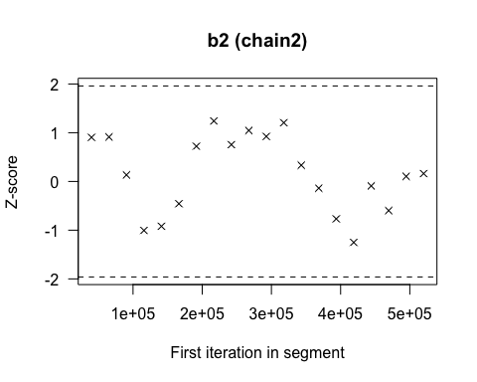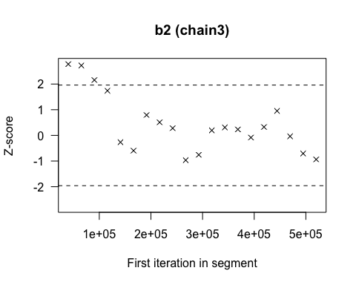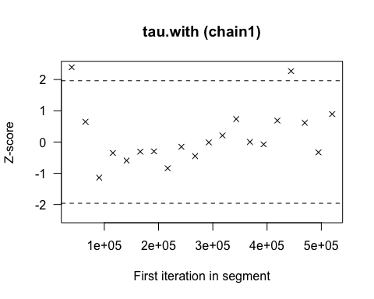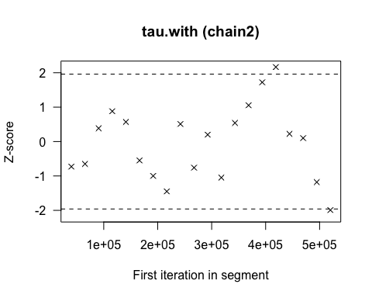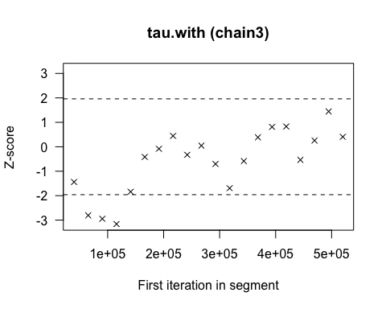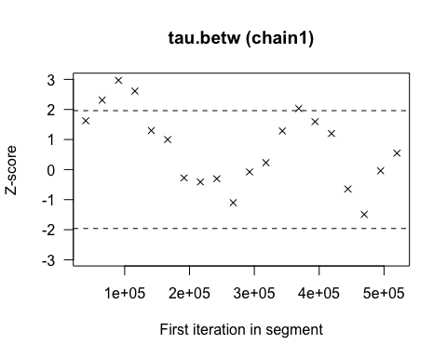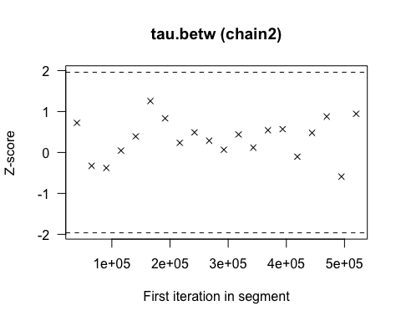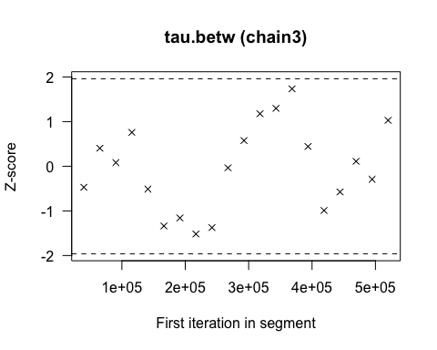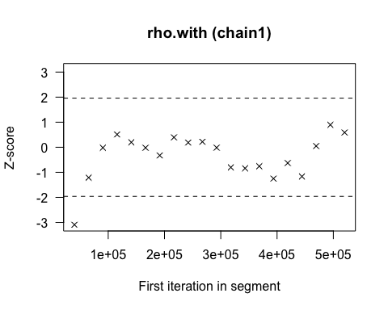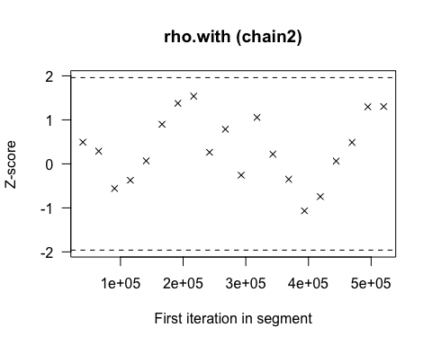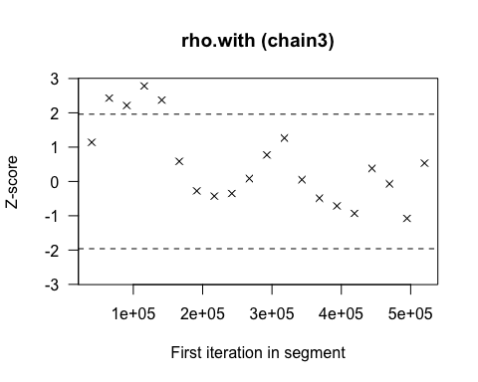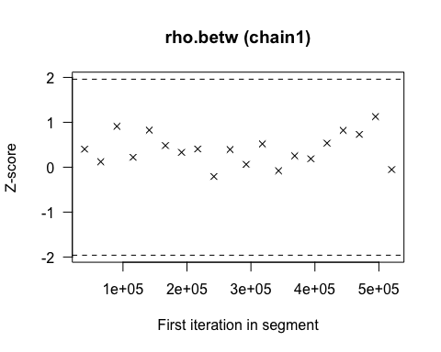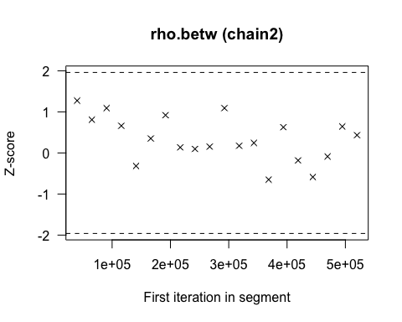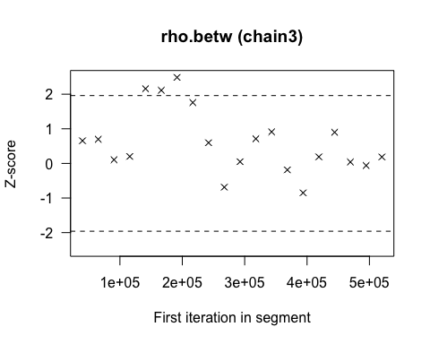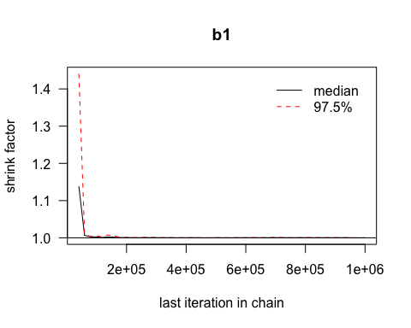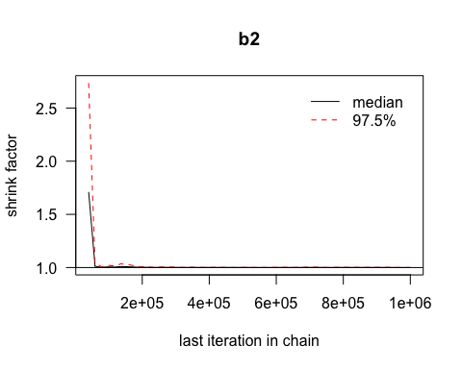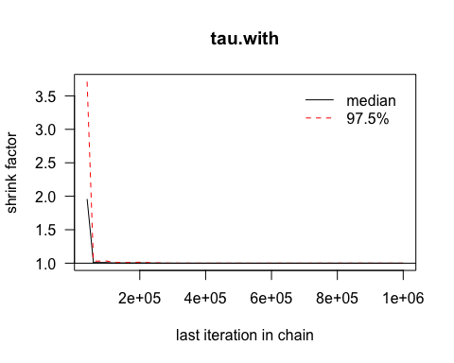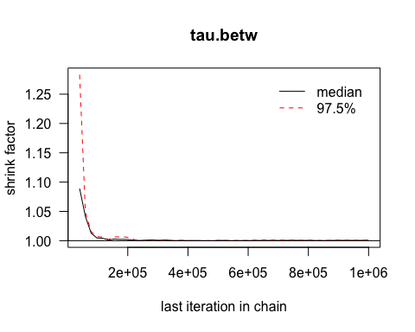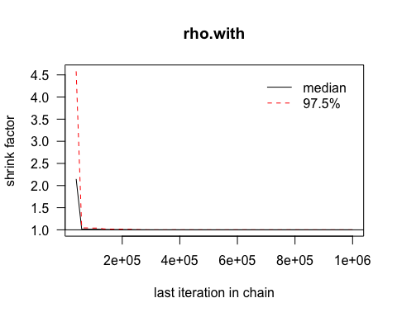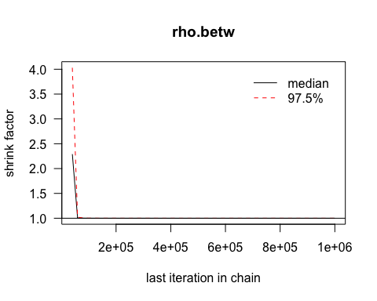

## Potential scale reduction factors:  
##   
## Point est. Upper C.I.  
## b1 1 1

## Potential scale reduction factors:  
##   
## Point est. Upper C.I.  
## b2 1 1

## Potential scale reduction factors:  
##   
## Point est. Upper C.I.  
## tau.with 1 1

## Potential scale reduction factors:  
##   
## Point est. Upper C.I.  
## tau.betw 1 1

## Potential scale reduction factors:  
##   
## Point est. Upper C.I.  
## rho.with 1 1

## Potential scale reduction factors:  
##   
## Point est. Upper C.I.  
## rho.betw 1 1

## b1   
## 58176.17

## b2   
## 11243.36

## tau.with   
## 18872.88

## tau.betw   
## 41222.58

## rho.with   
## 14250.11

## rho.betw   
## 89068.06

## [[1]]  
##   
## Quantile (q) = 0.025  
## Accuracy (r) = +/- 0.005  
## Probability (s) = 0.95   
##   
## Burn-in Total Lower bound Dependence  
## (M) (N) (Nmin) factor (I)  
## b1 63 86814 3746 23.2   
##   
##   
## [[2]]  
##   
## Quantile (q) = 0.025  
## Accuracy (r) = +/- 0.005  
## Probability (s) = 0.95   
##   
## Burn-in Total Lower bound Dependence  
## (M) (N) (Nmin) factor (I)  
## b1 69 93840 3746 25.1   
##   
##   
## [[3]]  
##   
## Quantile (q) = 0.025  
## Accuracy (r) = +/- 0.005  
## Probability (s) = 0.95   
##   
## Burn-in Total Lower bound Dependence  
## (M) (N) (Nmin) factor (I)  
## b1 90 124020 3746 33.1

## [[1]]  
##   
## Quantile (q) = 0.025  
## Accuracy (r) = +/- 0.005  
## Probability (s) = 0.95   
##   
## Burn-in Total Lower bound Dependence  
## (M) (N) (Nmin) factor (I)  
## b2 284 360609 3746 96.3   
##   
##   
## [[2]]  
##   
## Quantile (q) = 0.025  
## Accuracy (r) = +/- 0.005  
## Probability (s) = 0.95   
##   
## Burn-in Total Lower bound Dependence  
## (M) (N) (Nmin) factor (I)  
## b2 290 348638 3746 93.1   
##   
##   
## [[3]]  
##   
## Quantile (q) = 0.025  
## Accuracy (r) = +/- 0.005  
## Probability (s) = 0.95   
##   
## Burn-in Total Lower bound Dependence  
## (M) (N) (Nmin) factor (I)  
## b2 255 286671 3746 76.5

## [[1]]  
##   
## Quantile (q) = 0.025  
## Accuracy (r) = +/- 0.005  
## Probability (s) = 0.95   
##   
## Burn-in Total Lower bound Dependence  
## (M) (N) (Nmin) factor (I)  
## tau.with 952 1003289 3746 268   
##   
##   
## [[2]]  
##   
## Quantile (q) = 0.025  
## Accuracy (r) = +/- 0.005  
## Probability (s) = 0.95   
##   
## Burn-in Total Lower bound Dependence  
## (M) (N) (Nmin) factor (I)  
## tau.with 945 1084125 3746 289   
##   
##   
## [[3]]  
##   
## Quantile (q) = 0.025  
## Accuracy (r) = +/- 0.005  
## Probability (s) = 0.95   
##   
## Burn-in Total Lower bound Dependence  
## (M) (N) (Nmin) factor (I)  
## tau.with 558 583358 3746 156

## [[1]]  
##   
## Quantile (q) = 0.025  
## Accuracy (r) = +/- 0.005  
## Probability (s) = 0.95   
##   
## Burn-in Total Lower bound Dependence  
## (M) (N) (Nmin) factor (I)  
## tau.betw 258 283370 3746 75.6   
##   
##   
## [[2]]  
##   
## Quantile (q) = 0.025  
## Accuracy (r) = +/- 0.005  
## Probability (s) = 0.95   
##   
## Burn-in Total Lower bound Dependence  
## (M) (N) (Nmin) factor (I)  
## tau.betw 255 326706 3746 87.2   
##   
##   
## [[3]]  
##   
## Quantile (q) = 0.025  
## Accuracy (r) = +/- 0.005  
## Probability (s) = 0.95   
##   
## Burn-in Total Lower bound Dependence  
## (M) (N) (Nmin) factor (I)  
## tau.betw 228 242592 3746 64.8

## [[1]]  
##   
## Quantile (q) = 0.025  
## Accuracy (r) = +/- 0.005  
## Probability (s) = 0.95   
##   
## Burn-in Total Lower bound Dependence  
## (M) (N) (Nmin) factor (I)  
## rho.with 441 468090 3746 125   
##   
##   
## [[2]]  
##   
## Quantile (q) = 0.025  
## Accuracy (r) = +/- 0.005  
## Probability (s) = 0.95   
##   
## Burn-in Total Lower bound Dependence  
## (M) (N) (Nmin) factor (I)  
## rho.with 364 421564 3746 113   
##   
##   
## [[3]]  
##   
## Quantile (q) = 0.025  
## Accuracy (r) = +/- 0.005  
## Probability (s) = 0.95   
##   
## Burn-in Total Lower bound Dependence  
## (M) (N) (Nmin) factor (I)  
## rho.with 406 479428 3746 128

## [[1]]  
##   
## Quantile (q) = 0.025  
## Accuracy (r) = +/- 0.005  
## Probability (s) = 0.95   
##   
## Burn-in Total Lower bound Dependence  
## (M) (N) (Nmin) factor (I)  
## rho.betw 81 117909 3746 31.5   
##   
##   
## [[2]]  
##   
## Quantile (q) = 0.025  
## Accuracy (r) = +/- 0.005  
## Probability (s) = 0.95   
##   
## Burn-in Total Lower bound Dependence  
## (M) (N) (Nmin) factor (I)  
## rho.betw 64 75136 3746 20.1   
##   
##   
## [[3]]  
##   
## Quantile (q) = 0.025  
## Accuracy (r) = +/- 0.005  
## Probability (s) = 0.95   
##   
## Burn-in Total Lower bound Dependence  
## (M) (N) (Nmin) factor (I)  
## rho.betw 51 79203 3746 21.1

## [[1]]  
##   
## Stationarity start p-value  
## test iteration   
## b1 passed 1 0.101   
##   
## Halfwidth Mean Halfwidth  
## test   
## b1 passed 0.0214 5.49e-05   
##   
## [[2]]  
##   
## Stationarity start p-value  
## test iteration   
## b1 passed 1 0.659   
##   
## Halfwidth Mean Halfwidth  
## test   
## b1 passed 0.0214 5.41e-05   
##   
## [[3]]  
##   
## Stationarity start p-value  
## test iteration   
## b1 passed 1 0.1   
##   
## Halfwidth Mean Halfwidth  
## test   
## b1 passed 0.0213 5.51e-05

## [[1]]  
##   
## Stationarity start p-value  
## test iteration   
## b2 passed 1 0.233   
##   
## Halfwidth Mean Halfwidth  
## test   
## b2 passed -0.0388 0.000248   
##   
## [[2]]  
##   
## Stationarity start p-value  
## test iteration   
## b2 passed 1 0.886   
##   
## Halfwidth Mean Halfwidth  
## test   
## b2 passed -0.0388 0.00025   
##   
## [[3]]  
##   
## Stationarity start p-value  
## test iteration   
## b2 passed 1 0.108   
##   
## Halfwidth Mean Halfwidth  
## test   
## b2 passed -0.0386 0.000254

## [[1]]  
##   
## Stationarity start p-value  
## test iteration   
## tau.with passed 1 0.337   
##   
## Halfwidth Mean Halfwidth  
## test   
## tau.with passed 0.00778 7.18e-05   
##   
## [[2]]  
##   
## Stationarity start p-value  
## test iteration   
## tau.with passed 1 0.924   
##   
## Halfwidth Mean Halfwidth  
## test   
## tau.with passed 0.00774 7.28e-05   
##   
## [[3]]  
##   
## Stationarity start p-value  
## test iteration   
## tau.with passed 96001 0.0666   
##   
## Halfwidth Mean Halfwidth  
## test   
## tau.with passed 0.00773 7.36e-05

## [[1]]  
##   
## Stationarity start p-value  
## test iteration   
## tau.betw passed 1 0.129   
##   
## Halfwidth Mean Halfwidth  
## test   
## tau.betw passed 0.00507 6.78e-05   
##   
## [[2]]  
##   
## Stationarity start p-value  
## test iteration   
## tau.betw passed 1 0.498   
##   
## Halfwidth Mean Halfwidth  
## test   
## tau.betw passed 0.00504 6.6e-05   
##   
## [[3]]  
##   
## Stationarity start p-value  
## test iteration   
## tau.betw passed 1 0.761   
##   
## Halfwidth Mean Halfwidth  
## test   
## tau.betw passed 0.0051 6.84e-05

## [[1]]  
##   
## Stationarity start p-value  
## test iteration   
## rho.with passed 1 0.23   
##   
## Halfwidth Mean Halfwidth  
## test   
## rho.with passed -0.402 0.0157   
##   
## [[2]]  
##   
## Stationarity start p-value  
## test iteration   
## rho.with passed 1 0.821   
##   
## Halfwidth Mean Halfwidth  
## test   
## rho.with passed -0.395 0.0154   
##   
## [[3]]  
##   
## Stationarity start p-value  
## test iteration   
## rho.with passed 1 0.0609   
##   
## Halfwidth Mean Halfwidth  
## test   
## rho.with passed -0.387 0.0148

## [[1]]  
##   
## Stationarity start p-value  
## test iteration   
## rho.betw passed 1 0.806   
##   
## Halfwidth Mean Halfwidth  
## test   
## rho.betw passed -0.129 0.00667   
##   
## [[2]]  
##   
## Stationarity start p-value  
## test iteration   
## rho.betw passed 1 0.342   
##   
## Halfwidth Mean Halfwidth  
## test   
## rho.betw passed -0.128 0.00668   
##   
## [[3]]  
##   
## Stationarity start p-value  
## test iteration   
## rho.betw passed 1 0.166   
##   
## Halfwidth Mean Halfwidth  
## test   
## rho.betw passed -0.132 0.00662